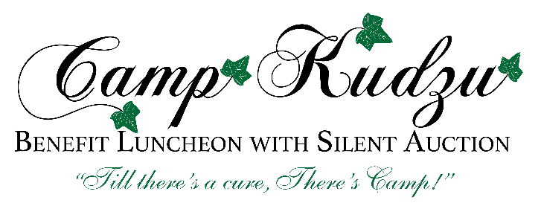

On behalf of Camp Kudzu’s campers, thank you for considering how you might support the 2017 Camp Kudzu Annual Benefit Luncheon and Silent Auction. Proceeds from the Benefit Luncheon will help fund Camp Kudzu’s vital type 1diabetes “T1D” management and education programs and send deserving kids to camp. This year’s Benefit Luncheon will be held on Tuesday, November 14, 2017, at a private country club in Buckhead.
Benefits to Silent Auction supporters include:

  - Direct product and service recognition among our +400 Atlanta-area attendees;
  - Item placement in electronic bidding system, made available to thousands of individuals via Camp Kudzu website and e-communications;
  - Opportunity to share your business cards or collateral material at the Luncheon.
Camp Kudzu is Georgia’s largest provider of diabetes education and support services for children living with T1D outside clinical settings. This year, we have served more than 700 children and provided over $160,000 in scholarships. More than 40% of our campers need financial assistance to fully participate. Your generous donations make this possible.

Some diabetes facts:

  - 6,000 children in Georgia are known to live with type 1 diabetes;
  - 400+ new diagnoses are made each year, and increasing;
  - Patients with diabetes are at high risk of developing life-threatening complications;
  - T1D is an autoimmune disease for which there is no cure
Camp Kudzu’s mission is to educate, empower and inspire children living with diabetes. For more than 18 years, Camp Kudzu has been a haven for children who live with T1D – providing a safe environment for kids to be kids with others experiencing the same challenges of T1D. At camp, kids learn both the skills needed to effectively manage prescribed regimen of care and the emotional demands of living with the disease. Your support will make a difference in the lives of hundreds of campers who call Camp Kudzu “home” every year.
Please view our video and see how your gift can lead to education, empowerment and inspiration in the lives of Camp Kudzu’s campers at www.campkudzu.org.
Sincerely,

Benefit Luncheon Committee
Camp Kudzu is a 501(c)3 nonprofit organization, Federal Tax ID 58-2449646.

